The term baby-boomers has been used to describe those born between 1946 and 1964 for decades. However, young people across the United States in recent years have begun to rally around the term as an insult intended to suggest an out-of-touch view with current events, shortening the term to “boomer” and primarily using it on the internet.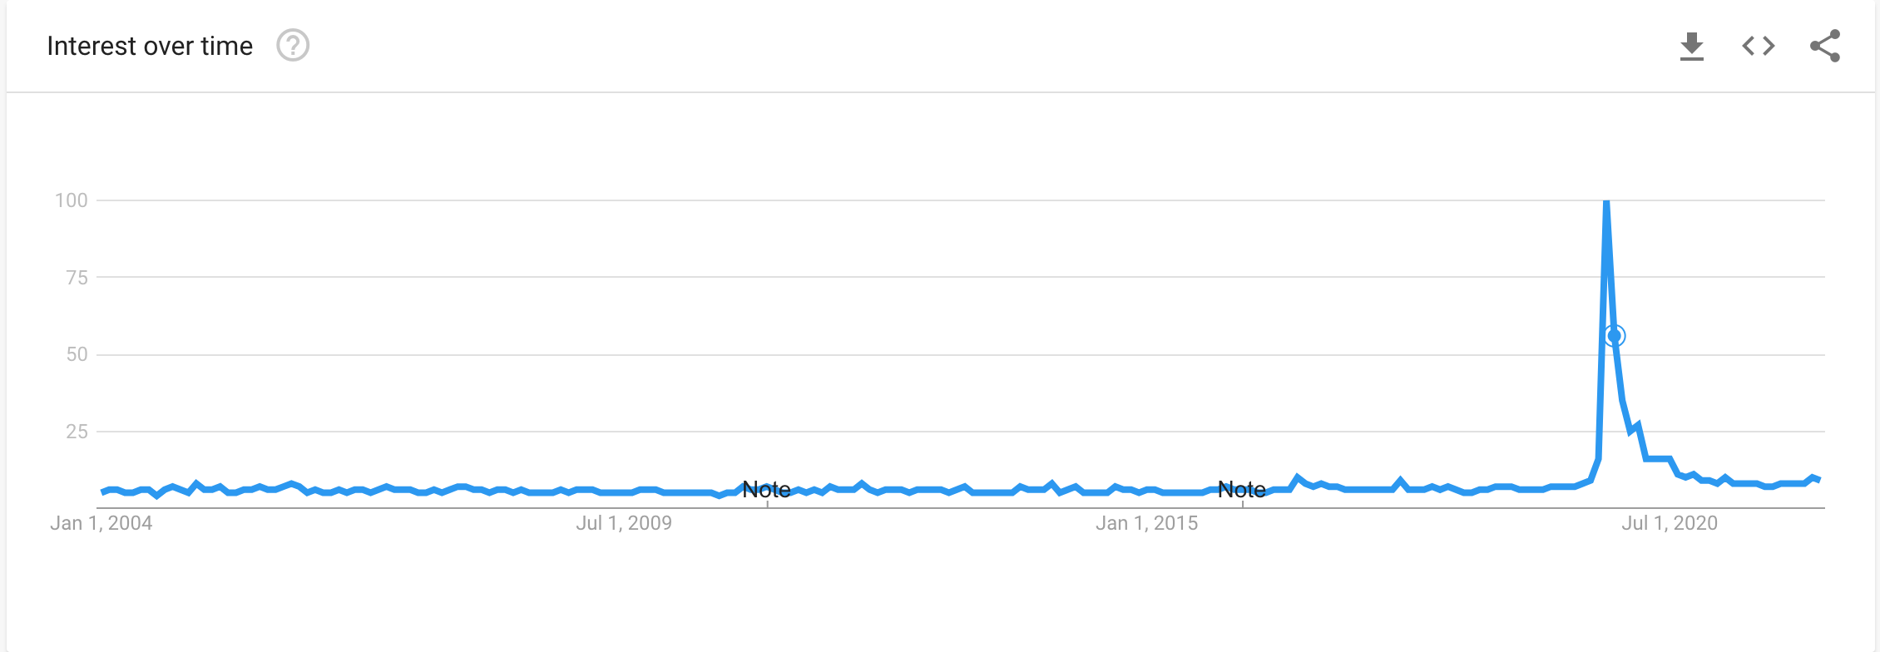

The trend cause some public outcry, but the term has since seemed to drastically drop from public interest, seeing a massive peak in November 2019 with a sharp drop off shortly thereafter.

However, the most frequent use of the term has not been specific to young people, but to Oklahomans.

Yes, even with the high rise in popularity internet trends have seen, particularly in recent years, nothing appears to be able to supplant the hold the University of Oklahoma’s fight song “Boomer Sooner” has on google trends.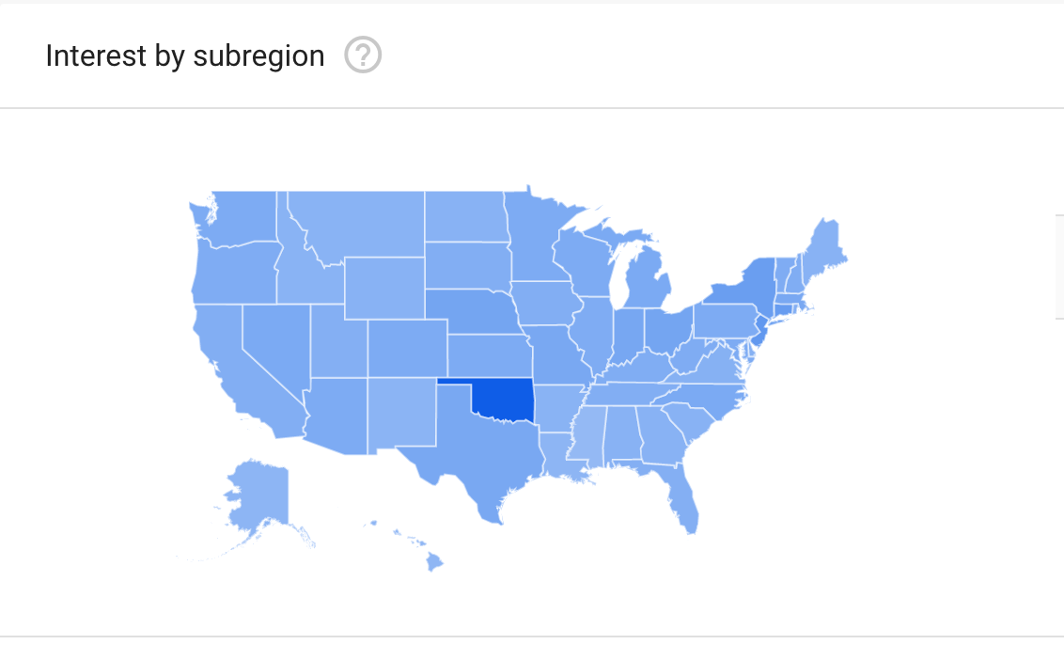

Certainly, Oklahoma joined the rest of the United States in the “boomer” slang for the baby boomer generation, also seeing a peak in the use of the term in November 2019. But in 2004, Oklahoma saw a large peak in use of the term as well, almost matching that experienced in 2019.

It seems no current trend can top the endurance of a college fight song.